SHELL SCRIPTING

- Write a Shell program to check the given number is even or odd

#!/bin/bash
echo "Enter a number:"
read number

if (( number % 2 == 0 )); then
echo "$number is even."
else
echo "$number is odd."
fi
output
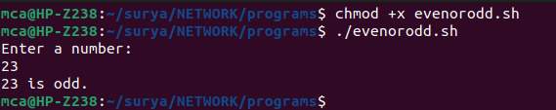

- Write a Shell program to check a leap year.

#!/bin/bash
echo "Enter a year:"
read year

if (( year % 4 == 0 && (year % 100 != 0 || year % 400 == 0) )); then
echo "$year is a leap year."
else
echo "$year is not a leap year."
fi

output

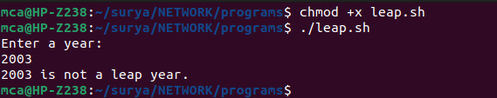

- Write a Shell program to find the area and circumference of a circle.

#!/bin/bash

echo "Enter the radius of the circle:"
read radius

area=$(echo "scale=2; 3.14 * $radius * $radius" | bc)

circumference=$(echo "scale=2; 2 * 3.14 * $radius" | bc)

echo "Area of the circle with radius $radius is: $area"
echo "Circumference of the circle with radius $radius is: $circumference"

output
